Conceptual model
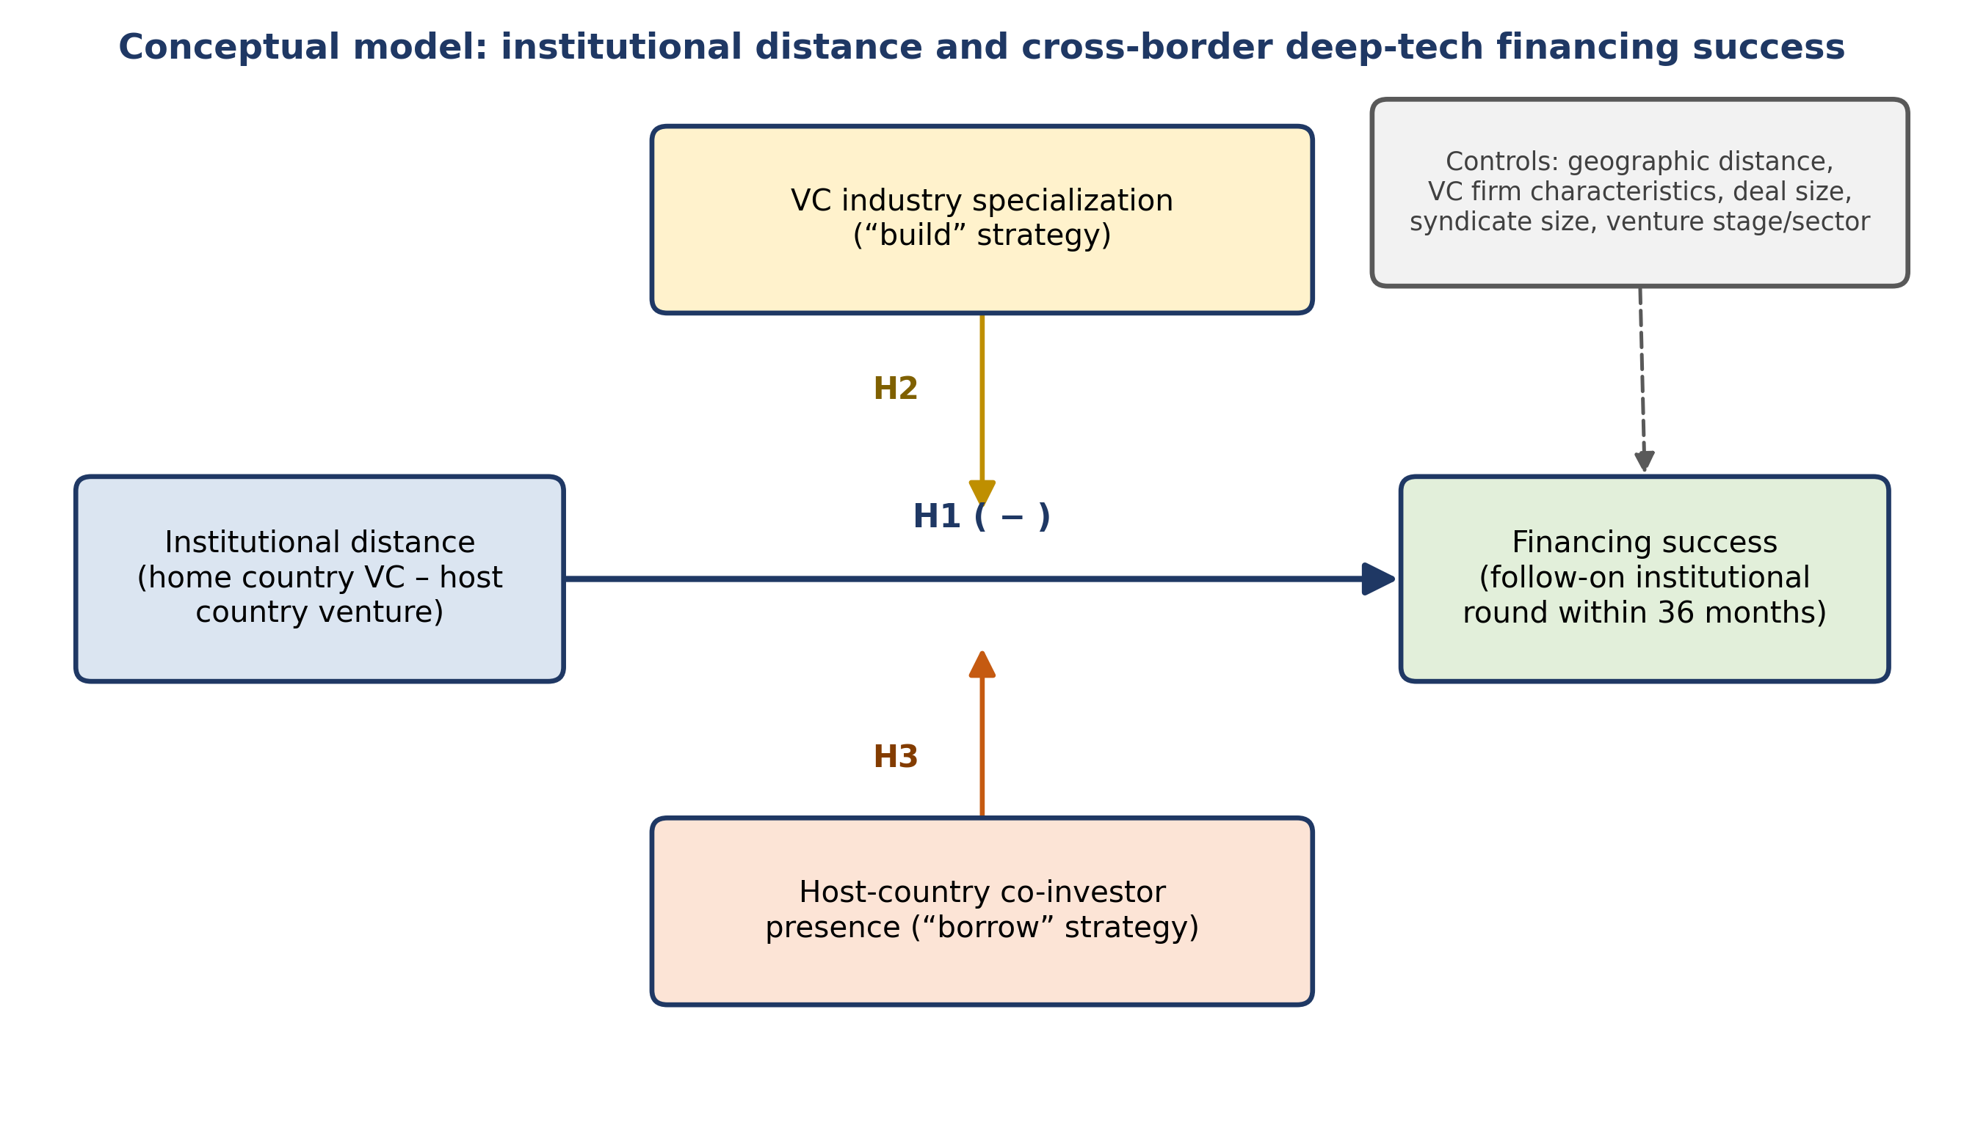

Hypotheses
H1: Institutional distance between a VC's home country and a venture's host country is negatively related to the venture's financing success.
This hypothesis states the baseline liability-of-foreignness effect implied by the research question, before any moderation is considered.
H2: VC industry specialization moderates the relationship between institutional distance and financing success, such that the negative relationship is weaker for VCs with higher specialization in the venture's sub-sector.
This hypothesis operationalizes the primary research question, namely to what extent specialization mitigates the distance-success relationship.
H3: Host-country co-investor presence moderates the relationship between institutional distance and financing success, such that the negative relationship is weaker when the lead investor syndicates with a co-investor headquartered in the venture's host country.
This hypothesis addresses the first half of the secondary research question, testing syndication as an alternative distance-mitigation strategy to specialization.
H4: The moderating effect of VC industry specialization on the institutional distance–financing success relationship depends on host-country co-investor presence.
This three-way interaction addresses the remainder of the secondary research question, namely whether specialization and syndication act as substitute or complementary strategies.

Data and measures
Variable | Role | Operational measure | Data source
Institutional distance | Independent variable | Aggregated regulative, normative, and cognitive distance between the lead VC's home country and the venture's host country, computed as a composite index from national governance and institutional-quality scores. | World Bank Worldwide Governance Indicators, merged with LSEG Workspace by headquarters country
Financing success | Dependent variable | Binary indicator equal to one if the venture secures a follow-on institutional financing round within thirty-six months of the focal round, zero otherwise. | LSEG Workspace deal and round history
VC industry specialization | Moderator (build) | Rolling share of the lead VC's financing rounds in the venture's deep-tech sub-sector over the preceding five years, relative to its total deal count in that window. | LSEG Workspace investor deal history and sub-sector classification
Host-country co-investor presence | Moderator (borrow) | Binary indicator equal to one if at least one syndicate member in the focal round is headquartered in the venture's host country, zero otherwise. | LSEG Workspace syndicate and participant records

Control variables
- Geographic distance between VC and venture headquarters, to separate the institutional component of distance from its purely geographic component.
- VC firm characteristics, including firm age, fund size, and total prior deal count, to rule out that specialization merely proxies for general firm capability or experience.
- Deal size, to account for the mechanical association between larger rounds and a higher likelihood of attracting follow-on financing.
- Syndicate size, to separate a diversification effect of having more co-investors from the effect of a co-investor's host-country identity specifically.
- Venture stage and sub-sector fixed effects, to absorb heterogeneity across the deep-tech sub-fields covered by the sample, such as semiconductors, biotechnology, robotics, and advanced materials.
- Investment-year fixed effects, to absorb VC funding-cycle effects that are common to all deals in a given year.
- Home-country and host-country fixed effects, to absorb time-invariant country-level factors unrelated to institutional distance itself.

